# VELAMMAL ENGINEERING COLLEGE

### (An Autonomous Institution)

**CHENNAI–600066**

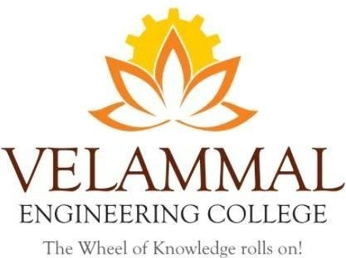

Special Lecture On “Home: The Incubator Innovative Ideas”

For 1st Year B.E / B.Tech Students

Organized By

DEPARTMENT OF

## PHYSICS

SUBMITTED TO

ENTREPRENEURSHIP DEVELOPMENT CELL LEMON IVY

### VELAMMAL ENGINEERING COLLEGE

**(An Autonomous Institution)**

# Department of Physics

1. Title of the Event : Special Lecture On “Home: The Incubator For Innovative Ideas” for 1st Year B.E / B.Tech Students
2. Resource Person **: Nil**

3. Date : 29-11-2024

1. Session Type : Offline
2. Program Type : Oral presentation
3. Annexure- I : List of Participants
4. Annexure- II : Brochure
5. Annexure- III : Photographs
6. Annexure- IV : Participants Feedback

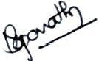 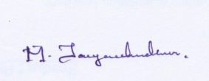

|  |  |
| --- | --- |
| **Dr. M. Jayachandiran** Assistant Professor Event Coordinator  Department of Physics | **Dr.S.Shahil Kirupavathy** Professor & Head Convener  Department of Physics |
|  |  |

### ANNEXURE-I

**Table 1: List of Participants**

|  |  |  |  |  |  |  |  |
| --- | --- | --- | --- | --- | --- | --- | --- |
| **S.No** | **Name of the Student1** | **S.No** | **Name of the Student2** | **S.No** | **Name of the Student3** | **S.No** | **Name of the Student3** |
| 1 | ABINESH KUMAR T | 18 | MUTHU SARAN L | 35 | CHARUMATHI S | 52 | SANJUKTA. V |
| 2 | ASISH IMMANUEL K S | 19 | PRANAV S | 36 | CHRISBINA SHERLEY A | 53 | SWATHIKA SHREE M |
| 3 | CHANDRAPRAKASH L | 20 | PURINI DATTA SAI MANIKANTA | 37 | DHARSHINI R | 54 | SWETHA NANTHINI N |
| 4 | DEEPAN A | 21 | SACHIN. V | 38 | DHIVYA M | 55 | SWETHA U |
| 5 | GOKUL K | 22 | SANTHOSH T | 39 | JOSELIN DOROTHY S | 56 | SREENIDHI P V |
| 6 | HARI HARAN S | 23 | SHYAM.M | 40 | KEERTHIKA R | 57 | YAZHMOZHIARASI A G |
| 7 | HASWANTH R | 24 | STEVENSON JONADAB.M | 41 | MADHUMITHA. M | 58 | HARINI. D |
| 8 | INIYAN SUBRAMANIYAN M A | 25 | TAMILVANAN. A | 42 | MANONMANI S | 59 | MADHUMITHA J |
| 9 | JABEZ IMMANUEL V | 26 | VAIDHEESHWAR M | 43 | MEENAKSHI V | 60 | PREETHIKAA K |
| 10 | JOSEPH ANISTO S | 27 | VASANTH. S.A | 44 | NANMA ELIZABETH GRACIOUS | 61 | Dr.J.Arumugam |
| 11 | KAMESH K J | 28 | VELUVUDIAR S | 45 | NITHYASHREE R | 62 | Dr.M.Jayachandiran |
| 12 | KARTHICK M | 29 | VINOTH. K | 46 | PRITHA S | 63 | Dr. Vinoth Kumar |
| 13 | KARTHIKEYAN.K | 30 | VISHWA S | 47 | PRIYA DHARSHINI D |  |  |
| 14 | KISHORE S | 31 | VISWAKUMAR K | 48 | PRIYADHARSHINI S |  |  |
| 15 | LAKSHMI PRASAD P | 32 | ANBU MOZHI A | 49 | RITHIKA S |  |  |
| 16 | MAHA VASANTH. M | 33 | AYESHA ALFIYA | 50 | RUPASHREE D |  |  |
| 17 | MONISH KUMAR.E | 34 | BAVISSHYA K P | 51 | SANDHIYA.M |  |  |

### ANNEXURE –II

### (BROUCHER)

**C:\Users\Dell\Desktop\2 event.tif**

*Figure 1: Poster for Special Lecture On “Home: The Incubator For Innovative Ideas”*

**ANNEXURE –III**

**Photographs**

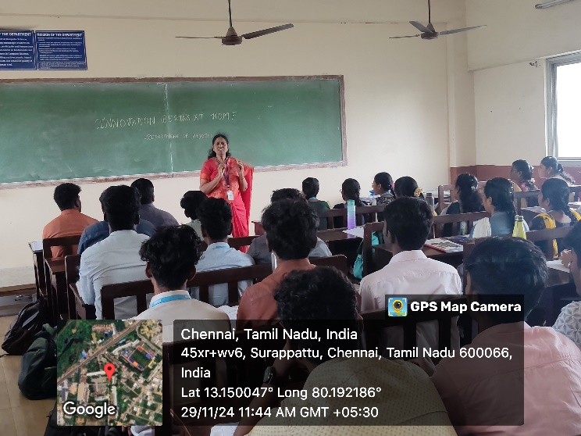

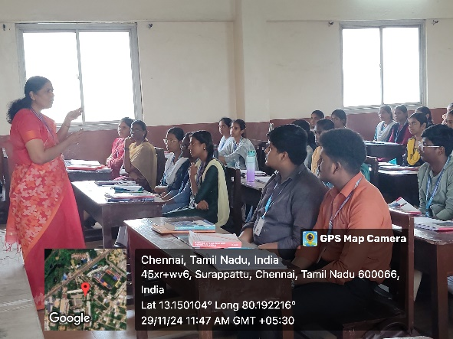

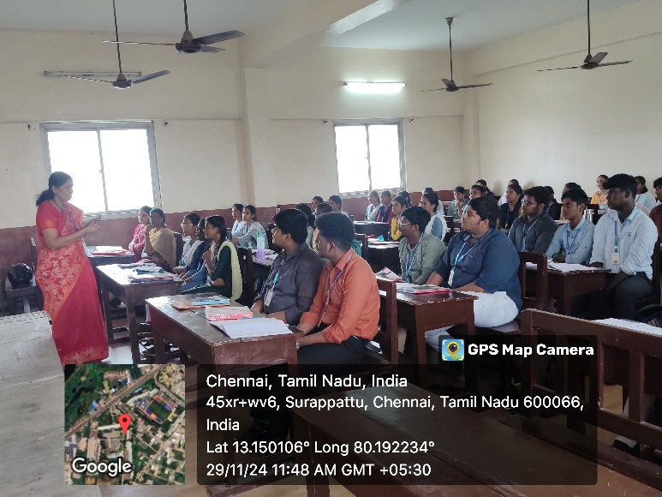

*Figure 2: Students are participate in the event : Special Lecture On “Home: The Incubator For Innovative Ideas*

**ANNEXURE –IV**

**Table 2: Participants Feedback**

|  |  |  |
| --- | --- | --- |
| **Sl.No** | **NAME** | **How was the Special Lecture On “Home: The Incubator For Innovative Ideas”** |
| 1 | VELUVUDIAR S | Helpful for future |
| 2 | VINOTH. K | Think hereafter home its self |
| 3 | VISHWA S | Informative |
| 4 | VISWAKUMAR K | Excellent |
| 5 | ANBU MOZHI A | Superb |
| 6 | AYESHA ALFIYA | Very Useful |
| 7 | BAVISSHYA K P | Inculcating research |
| 8 | SWETHA U | Good |
| 9 | SREENIDHI P V | Excellent |
| 10 | YAZHMOZHIARASI A G | Very Useful |